CURRICULUM VITAE

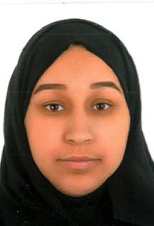
PERSONAL DETAILS:-
Name: Maream Mohammed Husain Ali
Nationality: Bahraini
C.P.R : 930308557
Marital Status : Married

Address: Flat 22 Building : 341 Road : 4113 Block 341
Contact No.: 33944150
Email : mrym74392@gmail.com

EDUCATION:-
- 19 Feb 2018 Bachelor in accounting – university of Bahrain
- 2011 Graduated for muharraq secondary School (Commerce)
Work Experience :-
- 2nd Jul 2017 – 2nd Dec 2017 Undergone Practical Training in Bahrain
Petroleum Company at Financial Accounting Department
- For 2 Weeks underwent training at sheikh salman Health Center in muharraq
Skills :-
- Familiar with Microsoft applications such as Ms Word , Ms Excel , Ms Power Point , Photoshop .. etc
- Self learning capabilities and willing to attend any course to improve my skills and knowledge
- High energy levels and capable of working under pressure and solving problems
- Creative optimistic , organized , initiative and helpful .

Training:-
- 17 Jul 2018 – 24 Oct 2019 – Underwnt training for CIPS ( Certificate in procurement and supply operations ) at origin training Center
Language :-
Very good in Arabic and English – Spoken and written
References :-
- Jameel Ahmed Abdul Nabi , manager , Financial Accounting , The Bahrain Petroleum Company BSC Mob 30699258
- Mohammed Al Banna , Business Development Manager , Origin Group
Mob : 37700422

